Tech Stack: Cypress and Java Script with Page Object Design Pattern(for UI Scripts only) with mochawesome HTML reporting.

**Task 1: Functional test scenario:**   
  
*Created tests in the format of a* ***page object pattern*** *and added four scripts as below:*

**Test Case 1(Negative):** Verify that the user is not able to log into demoblaze.com with an invalid username and assert the error message

**Test Case 2(Negative):** Verify that the user is not able to log into demoblaze.com with an invalid password and assert the error message

**Test Case 3(Positive):** Verify that the user login is successful with valid credentials

**Test Case 4(Positive):** Verify the Add Cart feature:

Steps: a. Select a particular product and add it to cart multiple times

b. Verify that product is added to card multiple times

c. Verify that product total price displayed in cart is as expected.

Screenshot:

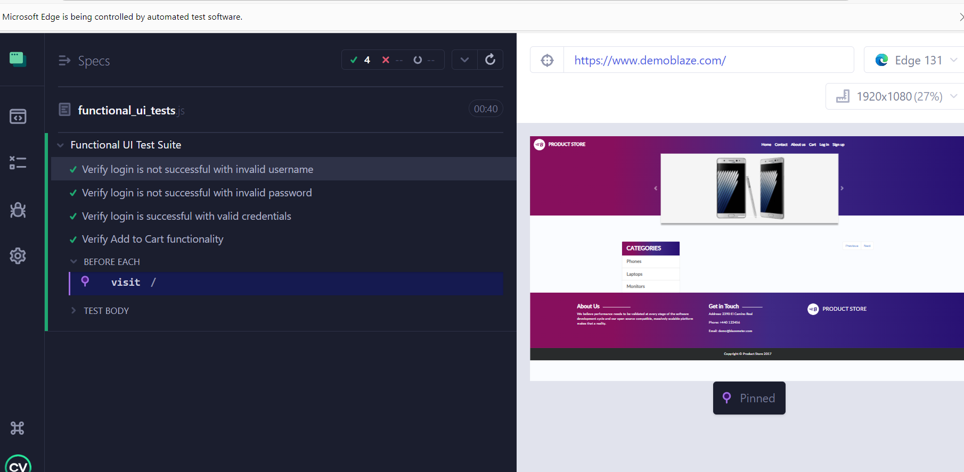  
HTML Report:  
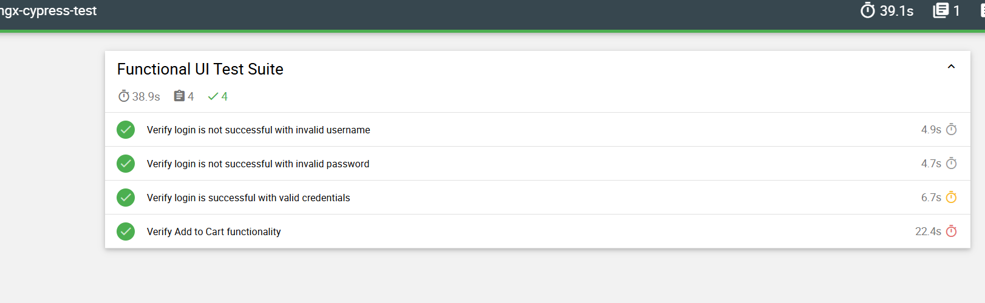

**Task 2 : API test scenario**

*Created four API tests using cypress as below:***Test Case 1(Positive):** Verify that add new pet is successful.

**Test Case 2(Negative):** Verify that the user is not successful for invalid request

**Test Case 3(Positive):** Verify that find a pet by Id is successful.

**Test Case 4(Positive):** Verify that petId not found for invalid petId.

Screenshot:

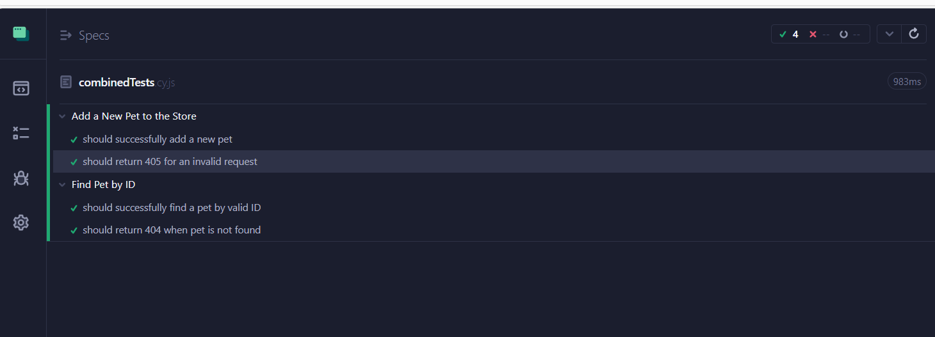

**HTML Report:**